TAKING SAFEY IN TRACKLESS MACHINE OPERATORS TO A NEW LEVEL
At the very heart of safe operating is the ability of an operator to be able to SEE (recognise- what he is looking at), PREDICT a possible danger – DECIDE (make a judgement call quick enough) and ACT (appropriately and quickly). We call this Visual Performance. This is we believe partly why the MHSA regulations are calling for pre-selection of drivers on physical and psychological criterion.
While the thinking behind this is sound, we all know that health and age can change a person’s ability to SEE-PREDICT- DECIDE and ACT, so the problem is not completely solved through pre-selection. The question is also what do we do with a driver with a poor score?
Improving an operator’s ability to SEE-PREDICT-DECIDE and ACT:
Dr Sherylle Calder from the Sports Science Institute at Stellenbosch University, has gained international acclaim for improving the Visual Performance of top sports teams with a product called Eyegym.
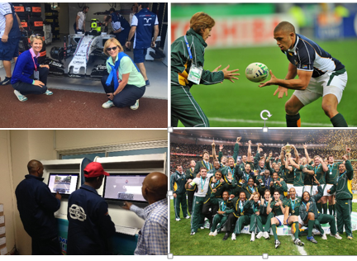
Eyegym Trucker is a product that has been adopted for Drivers of commercial and heavy equipment and is offered through the DIB. It is a PC based training tool focussed on improving reaction, eye speed, Peripheral vision, Hand eye coordination, and Hand eye reaction.
Massive improvement in Tanker Driver safety
Unitrans is one of the Top transport companies in Southern Africa and were keen to take safety to a new level. DIB through their Eyegym trucker did an intervention to improve their driver’s SEE-PREDICT-DECIDE-Act ability. Drivers were tracked over a 2 year period. The results were staggering and described in the table below.
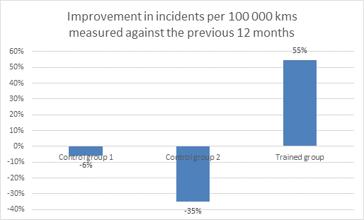
Interestingly 92% of drivers who took the test said that Eyegym had improved their ability to identify hazards and react to them.
In 2014 a trial was also done to see if the Eyegym effect could be seen on Drivers taking the Dover test. The results are shown below:

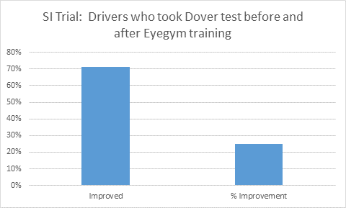
Discovery Insure have seen the value in this approach and have some 20 000 drivers who use the Eyegym program, and reward them with lower insurance premiums, so businesses are seeing the value in this approach.

Discussion of results:
Lately the DIB team have spent a lot of time underground and the application of the technology is particularly striking. Dr Calder explains that an Eyegym fit driver will handle fatigue a great deal better than and a non Eyegym fit driver and says that Contrast sensitivity (handling changes in bright light to dark conditions) can be improved.
We are also learning how the Technology should be applied in a mine in order that it becomes part of the everyday routine with the least disruption to operations.

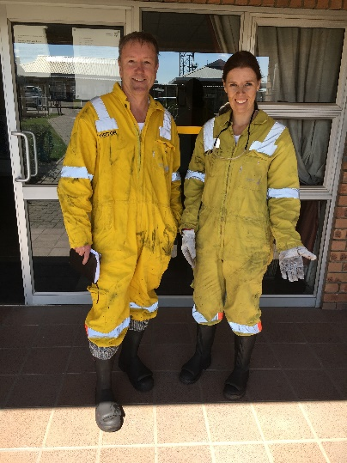

Should you require more information, please contact
Andrew Crickmay
www.driverib.com
Andrew@driverib.com
0829018498

